**Sertainty UXP Technology**

**Mobile Application / Sample Android app**

Copyright © 2020, Sertainty Corporation

Sertainty Android Sample

Pre-requisites:

Android SDK Version: >= 26.1.1, NDK Version: >= 20.1.5948944, JDK: 1.8

1. Start Android Studio.

1. Select “Import project”.
2. Browse to SertaintyAndroid/sample/SertaintyAndroidSample folder and click “Open”.
3. When prompted “Gradle Sync” click Ok to recreate wrappers using latest Gradle version.

1. SertaintyAndroidSample already has copies of necessary code, libraries, and other artifacts as mentioned here:
   1. SertaintyAndroid/java/org has been copied to SertaintyAndroidSample/app/src/main/java/org.
   2. Sertainty folder from SertaintyAndroid is copied to SertaintyAndroidSample/app/src/main/assets/Sertainty.
   3. Sample program assets - data.pdf, data1.pdf, sampleid.xml – are copied from SertaintyAndroid/Sertainty/example to SertaintyAndroidSample/app/src/main/assets/Sertainty/example.
   4. Sertainty Android Core and JNI libraries for x86 and x84_64 platforms are present in SertaintyAndroid/Libraries under x86 and x86_64 folders based on their targeted processor architecture. These folders are copied to SertaintyAndroidSample/app/src/main/jniLibs.
2. Optional: Modify SertaintyAndroidSample/app/src/main/java/org/Sertainty/Library.java file and change the library file name for debug or release to match the copied libraries.
3. Project is now ready to be compiled.
4. Using AVD Manager, create an Android Emulator device for API 24 with x86 or x86_64 architecture.
5. Launch device.
6. Upload a license file to the device.
7. Launch the SertaintyAndroid program to run on the device.

App should ask permission to access files. Allow.

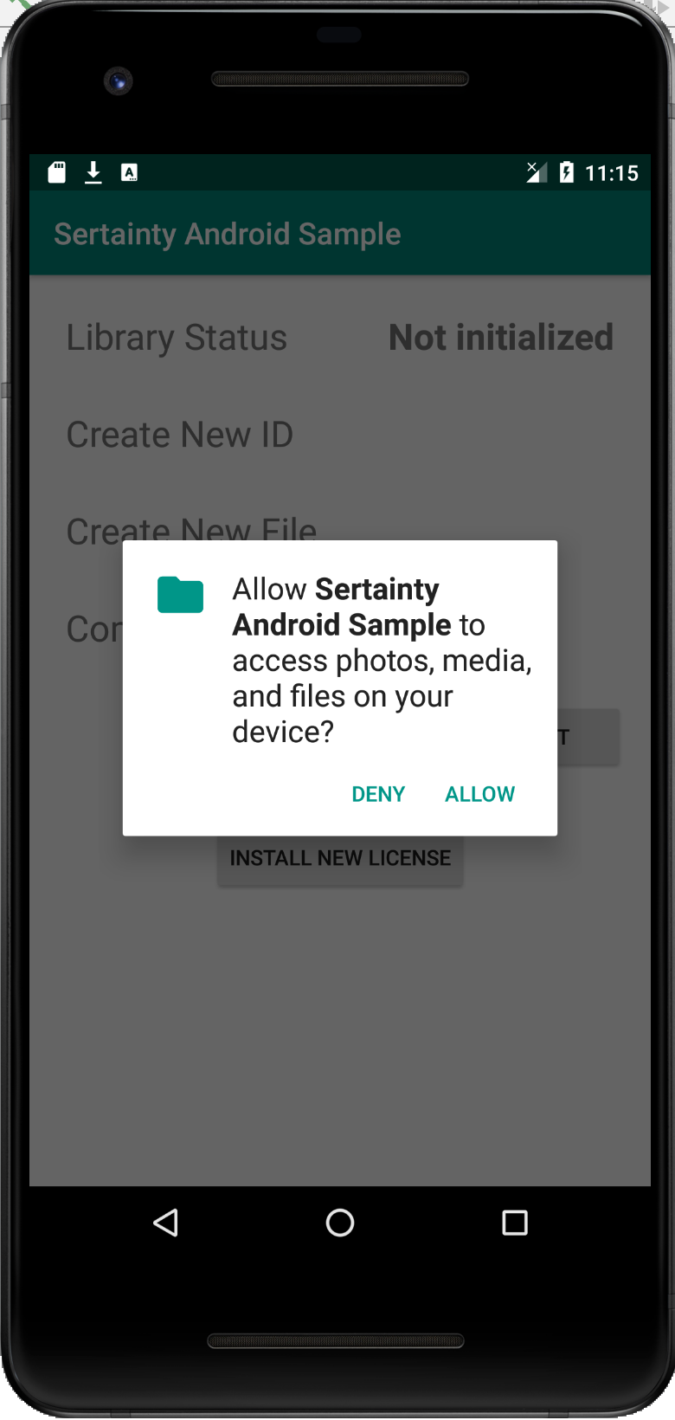

1. This should copy assets/Sertainty/example folder to /sdcard/Sertainty/example on the device.

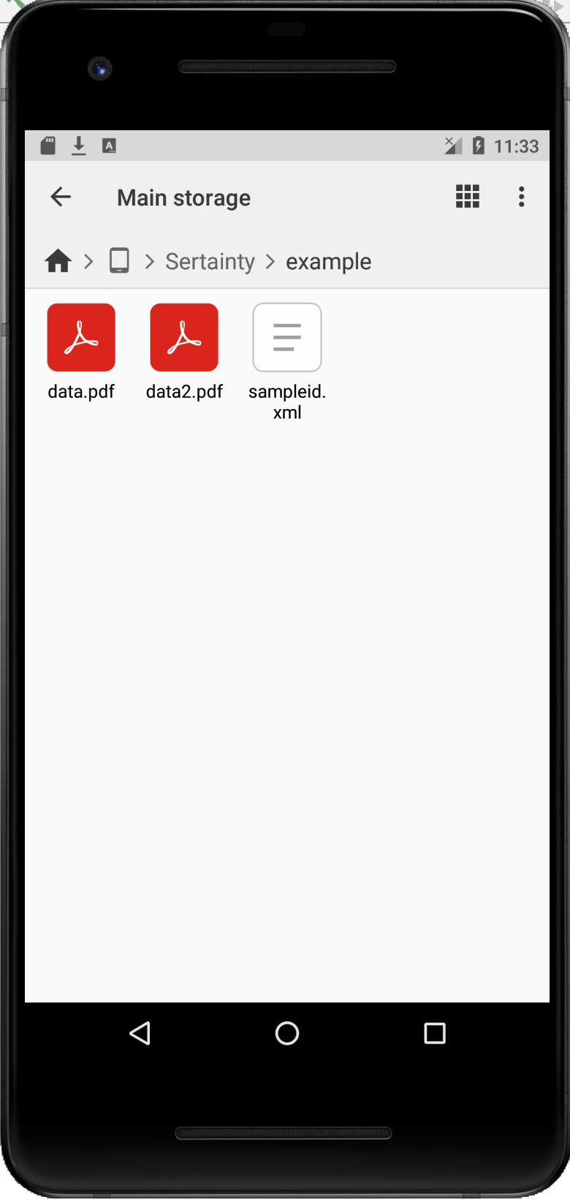

1. Click “Install New License” to browse and select license file. Once installed, “Library Status” should update accordingly.

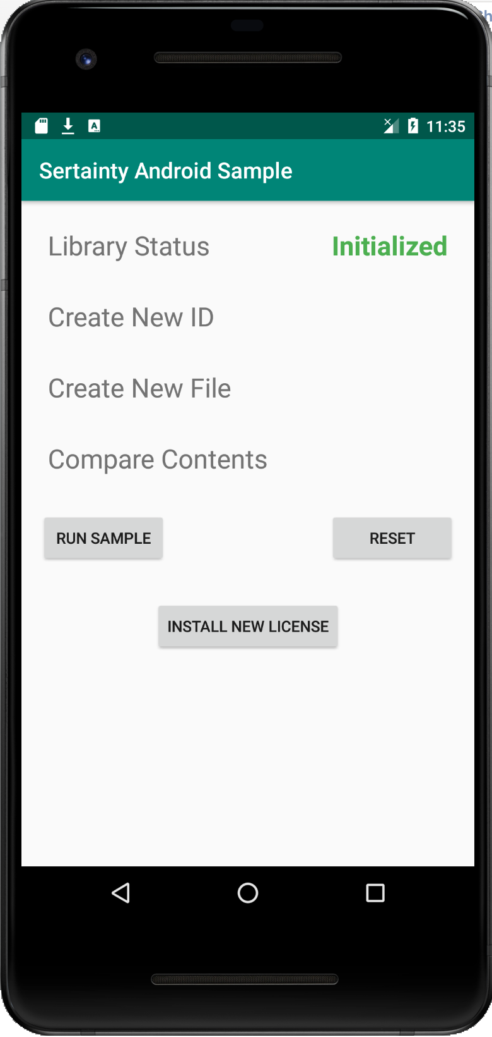

1. Click “Run Sample” to run through creating new ID, creating new UXP with created ID, and compare file contents. Statuses will update accordingly.

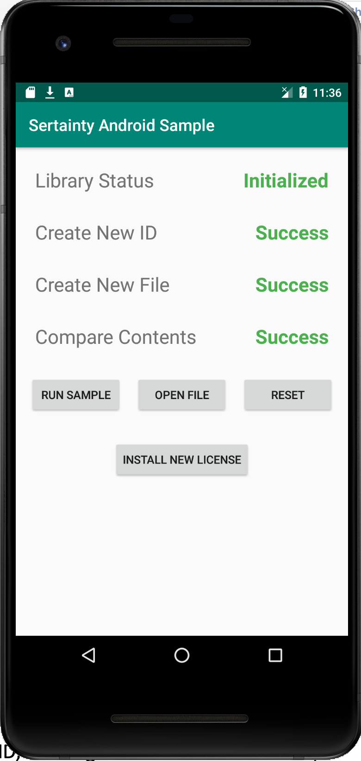

1. If all tests run correctly and UXP is created in Sertainty/example folder, “Open File” button should become visible. Click it and browse to create UXP (or any UXP on device) and start authentication.

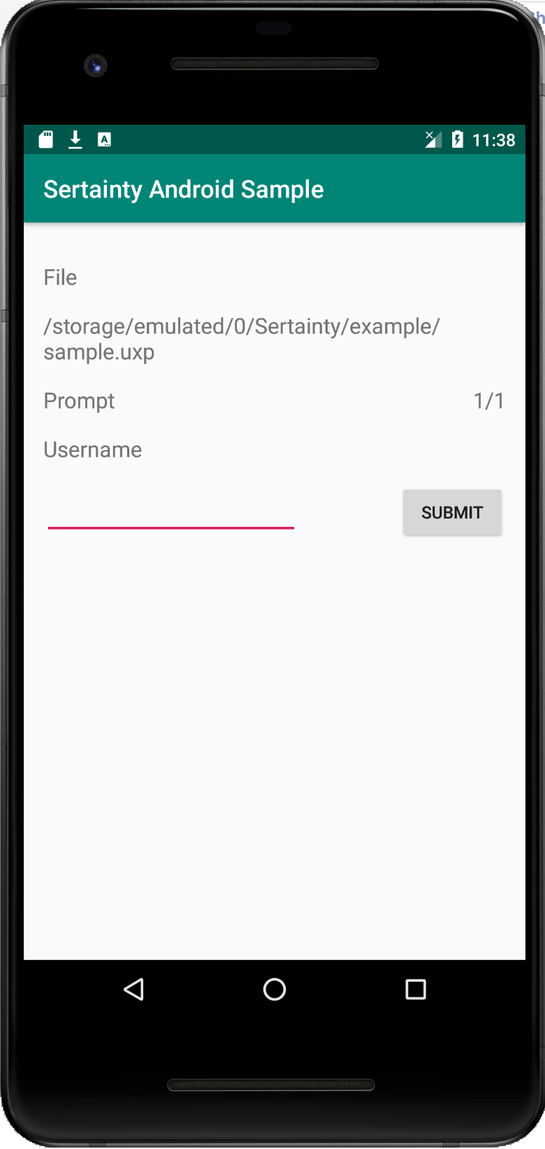

1. Successful authentication will allow you to browse the internal contents of the UXP.

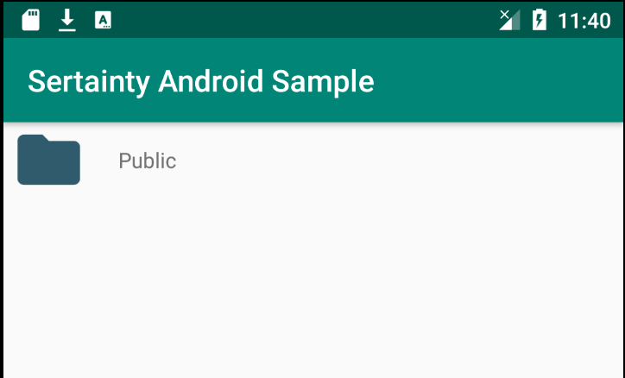

1. Clicking will open virtual folder or open the virtual file accordingly.

